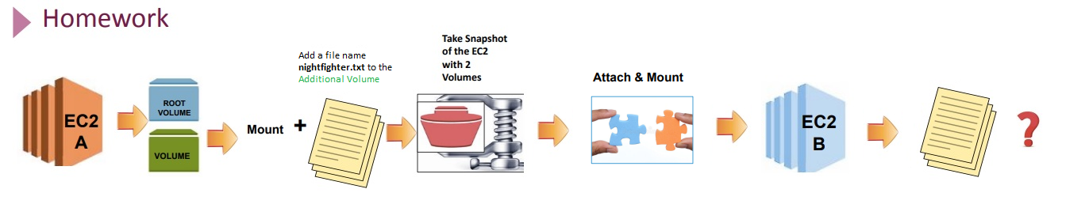

Diagram Attach & Mount

HRN@DESKTOP-7K8096H MINGW64 ~

$ cd Downloads/

HRN@DESKTOP-7K8096H MINGW64 ~/Downloads

$ ssh -i "FirstKey.pem" ec2-user@ec2-3-83-130-89.compute-1.amazonaws.com

Last login: Thu Feb 10 21:44:20 2022 from 88.236.107.233

__| __|_ )

_| ( / Amazon Linux 2 AMI

___|\___|___|

https://aws.amazon.com/amazon-linux-2/

3 package(s) needed for security, out of 6 available

Run "sudo yum update" to apply all updates.

[ec2-user@ip-172-31-95-7 ~]$ lsblk

NAME MAJ:MIN RM SIZE RO TYPE MOUNTPOINT

xvda 202:0 0 8G 0 disk

└─xvda1 202:1 0 8G 0 part /

xvdf 202:80 0 12G 0 disk

[ec2-user@ip-172-31-95-7 ~]$ df -h

Filesystem Size Used Avail Use% Mounted on

devtmpfs 475M 0 475M 0% /dev

tmpfs 483M 0 483M 0% /dev/shm

tmpfs 483M 404K 483M 1% /run

tmpfs 483M 0 483M 0% /sys/fs/cgroup

/dev/xvda1 8.0G 1.6G 6.5G 19% /

tmpfs 97M 0 97M 0% /run/user/1000

[ec2-user@ip-172-31-95-7 ~]$ export PS1="\[\e[32m\][\[\e[m\]\[\e[31m\]\u\[\e[m\]\[\e[33m\]@\[\e[m\]\[\e[32m\]\h\[\e[m\]:\[\e[36m\]\w\[\e[m\]\[\e[32m\]]\[\e[m\]\[\e[32;47m\]\\$\[\e[m\] "

[ec2-user@ip-172-31-95-7:~]$ lsblk

NAME MAJ:MIN RM SIZE RO TYPE MOUNTPOINT

xvda 202:0 0 8G 0 disk

└─xvda1 202:1 0 8G 0 part /

xvdf 202:80 0 12G 0 disk

[ec2-user@ip-172-31-95-7:~]$ sudo file -s /dev/xvdf

/dev/xvdf: Linux rev 1.0 ext4 filesystem data, UUID=81363a9f-1c36-451f-9c3a-6eaaa98f66f1 (needs journal recovery) (extents) (64bit) (large files) (huge files)

[ec2-user@ip-172-31-95-7:~]$ sudo resize2fs /dev/xvdf

resize2fs 1.42.9 (28-Dec-2013)

Please run 'e2fsck -f /dev/xvdf' first.

[ec2-user@ip-172-31-95-7:~]$ ^C

[ec2-user@ip-172-31-95-7:~]$ sudo e2fsck -f /dev/xvdf

e2fsck 1.42.9 (28-Dec-2013)

/dev/xvdf: recovering journal

Pass 1: Checking inodes, blocks, and sizes

Pass 2: Checking directory structure

Pass 3: Checking directory connectivity

Pass 4: Checking reference counts

Pass 5: Checking group summary information

Free blocks count wrong (2538303, counted=2538302).

Fix<y>? yes

Free inodes count wrong (655349, counted=655348).

Fix<y>? yes

/dev/xvdf: ***** FILE SYSTEM WAS MODIFIED *****

/dev/xvdf: 12/655360 files (0.0% non-contiguous), 83138/2621440 blocks

[ec2-user@ip-172-31-95-7:~]$ ls -lh /mnt/2nd-vol/

total 0

[ec2-user@ip-172-31-95-7:~]$ cd /mnt/2nd-vol

[ec2-user@ip-172-31-95-7:/mnt/2nd-vol]$ ls

[ec2-user@ip-172-31-95-7:/mnt/2nd-vol]$ cd

[ec2-user@ip-172-31-95-7:~]$ ls

[ec2-user@ip-172-31-95-7:~]$ sudo mount /dev/xvdf /mnt/2nd-vol/

[ec2-user@ip-172-31-95-7:~]$ lsblk

NAME MAJ:MIN RM SIZE RO TYPE MOUNTPOINT

xvda 202:0 0 8G 0 disk

└─xvda1 202:1 0 8G 0 part /

xvdf 202:80 0 12G 0 disk /mnt/2nd-vol

[ec2-user@ip-172-31-95-7:~]$ df -h

Filesystem Size Used Avail Use% Mounted on

devtmpfs 475M 0 475M 0% /dev

tmpfs 483M 0 483M 0% /dev/shm

tmpfs 483M 404K 483M 1% /run

tmpfs 483M 0 483M 0% /sys/fs/cgroup

/dev/xvda1 8.0G 1.6G 6.5G 19% /

tmpfs 97M 0 97M 0% /run/user/1000

/dev/xvdf 9.8G 37M 9.2G 1% /mnt/2nd-vol

[ec2-user@ip-172-31-95-7:~]$ cd /mnt/2nd-vol

[ec2-user@ip-172-31-95-7:/mnt/2nd-vol]$ ls

geceyarisi.txt lost+found

[ec2-user@ip-172-31-95-7:/mnt/2nd-vol]$ sudo resize2fs /dev/xvdf

resize2fs 1.42.9 (28-Dec-2013)

Filesystem at /dev/xvdf is mounted on /mnt/2nd-vol; on-line resizing required

old_desc_blocks = 2, new_desc_blocks = 2

The filesystem on /dev/xvdf is now 3145728 blocks long.

[ec2-user@ip-172-31-95-7:/mnt/2nd-vol]$ lsblk

NAME MAJ:MIN RM SIZE RO TYPE MOUNTPOINT

xvda 202:0 0 8G 0 disk

└─xvda1 202:1 0 8G 0 part /

xvdf 202:80 0 12G 0 disk /mnt/2nd-vol

[ec2-user@ip-172-31-95-7:/mnt/2nd-vol]$